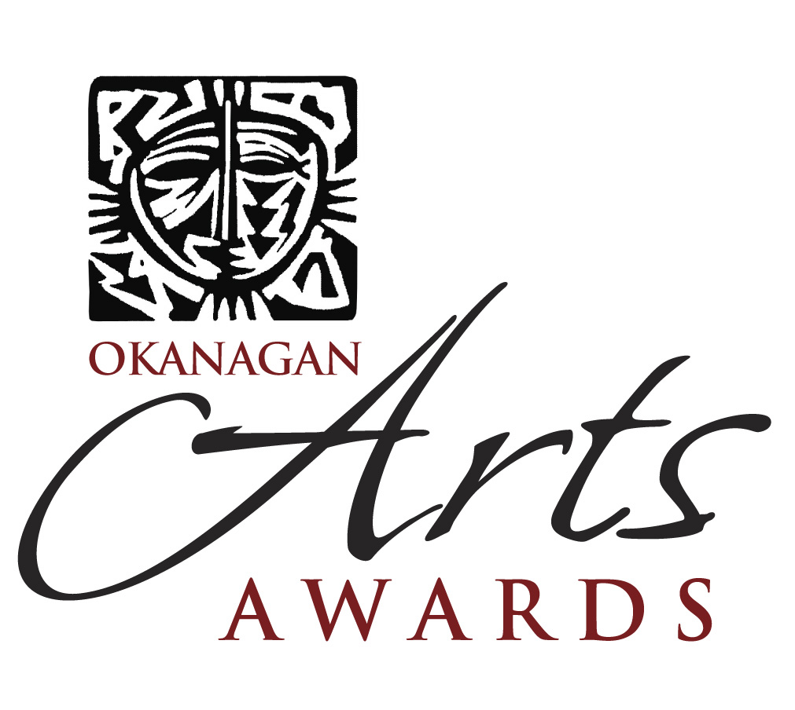

________________________________________________________________________

Dear Anita McComas,

Thank you for nominating Dennis Weber for an Okanagan Arts Award! It is only with the effort of a nominator that an award can be given, so thank you for taking the time to prepare a nomination. We wish Dennis all the best as the Jury Committee reviews all the nominations.

For your interest, there were a total of 32 nominations in all categories, from various communities within the Okanagan Valley.

The Okanagan Arts Awards will be held at the Kelowna Community Theatre on Saturday, February 25th. The reception will start at 6:30 pm in the Foyer where there will be a “Meet the Nominees” opportunity along with a Silent Auction. Upon entering the Theatre, you will be presented with delicious morsels prepared by the ARTSCO Culinary Arts Sponsor, Chef Michael Lyon. These decadent morsels will be paired together perfectly with sparkling wines provided by Summerhill Winery.
Following the reception, a Concert will feature the award presentations and performances in all areas of the arts. In closing, a dessert reception and the silent auction results will be announced.

In addition, an official after party will be held at Hanna’s Lounge & Grill for another chance to celebrate this remarkable event. Be sure to keep your tickets from the Okanagan Arts Awards for admittance.

We feel that it is important to acknowledge those who produce, support, and increase the profile of the arts in our community. Overall, this evening will feature the amazing artists along with great food and entertainment for everyone to enjoy!

We look forward to meeting you at this event. Tickets are now available for $35 and are available through Select Your Tickets at the Rotary Centre for the Arts in Kelowna, 250-717-5304, or at this link: http://www.selectyourtickets.com/event.php?event_id=746

If you have any questions about this information, please feel free to contact me.

Sincerely,

Andrea Patterson, Event Coordinator
Arts Council of the Central Okanagan
Tel: 250-861-4123
E-mail: memberservices@artsco.ca
Web: www.artsco.ca

